

Practices for Secure Software Report

Table of Contents
Practices for Secure Software Report 1
Document Revision History 3
Client 3
Instructions 3
Developer 4
1. Algorithm Cipher 4
2. Certificate Generation 5
3. Deploy Cipher 5
4. Secure Communications 6
5. Secondary Testing 7
6. Functional Testing 8
7. Summary 9
8. Industry Standard Best Practices 11

Document Revision History

Version | Date | Author | Comments
1.0 | 12/14/2025 | Grant McCord

Client



Instructions

Submit this completed practices for secure software report. Replace the bracketed text with the relevant information. You must document your process for writing secure communications and refactoring code that complies with software security testing protocols.

- Respond to the steps outlined below and include your findings.
- Respond using your own words. You may also choose to include images or supporting materials. If you include them, make certain to insert them in all the relevant locations in the document.
- Refer to the Project Two Guidelines and Rubric for more detailed instructions about each section of the template.

Developer
Grant McCord

Algorithm Cipher

Artemis Financial requires robust mechanisms to ensure the integrity and authenticity of its financial and business data during storage and transfer. For this purpose, the Secure Hash Algorithm 256 (SHA-256) provides a reliable solution. SHA-256 is part of the SHA-2 family of cryptographic hash functions, which were developed by the National Institute of Standards and Technology (NIST) to produce a fixed-size, 256-bit hash value for any input data (NIST, 2015). The primary function of SHA-256 is to create a unique digital fingerprint of a file or message, which can then be used to verify that the data has not been altered in transit or storage.
Hash functions like SHA-256 are particularly effective for file verification because they are deterministic, collision-resistant, and computationally efficient. Deterministic means that the same input will always produce the same hash output, allowing Artemis Financial to consistently verify files. Collision resistance ensures that it is computationally infeasible for two different files to produce the same hash, providing strong protection against tampering or accidental corruption (Stallings, 2020). Additionally, SHA-256 is efficient enough to handle large data sets, making it well suited for a web application that processes substantial financial records.
In Artemis Financial’s web application, SHA-256 can generate a checksum for each transmitted file. The sender computes the file’s hash and sends it with the data, while the receiver independently computes the hash to verify integrity. SHA-256 works alongside HTTPS and secure coding practices to support the technical safeguards required by regulations such as GLBA, SOX, and PCI DSS (FTC, n.d.; SEC, n.d.; PCI Security Standards Council, n.d.).
Overall, SHA-256 is a reliable, industry-standard method for file verification, allowing Artemis Financial to maintain trust, protect sensitive information, and support audits in its web application.

Certificate Generation
Insert a screenshot below of the CER file.

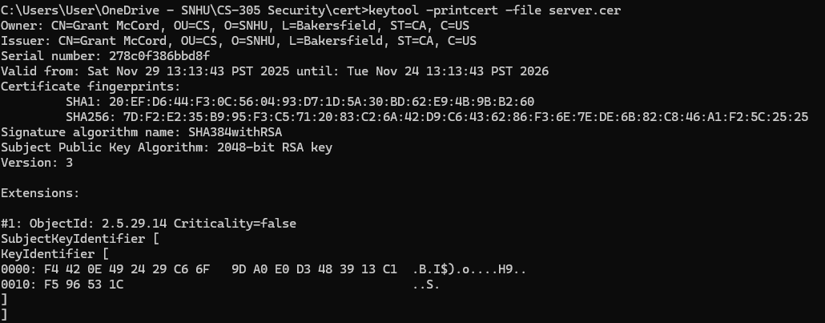

Deploy Cipher

In the screenshot below, the same input data—my name, “Grant McCord”—is hashed using this algorithm. The hashing process produces a fixed-length output (checksum), which is shown below the input. This demonstrates how SHA-256 consistently generates the same checksum for identical input data, verifying data integrity. A timestamp was added to demonstrate this was added to the new code’s assignment and screenshot was generated new (not copied from previous assignments).
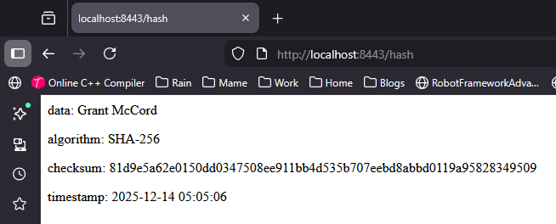

Secure Communications
Insert a screenshot below of the web browser that shows a secure webpage.
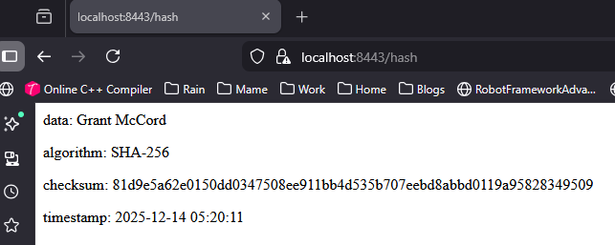

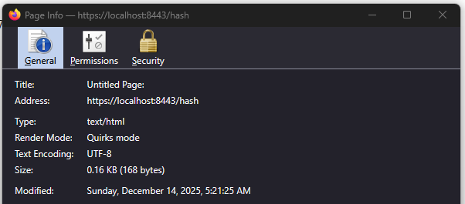

Secondary Testing
Insert screenshots below of the refactored code executed without errors and the dependency-check report.

Since I have Java 25, it was safe to upgrade the project to Spring Boot 4.0.0 and update all major dependencies to their latest compatible versions. This was done to rectify the critical errors and patch critical security vulnerabilities.
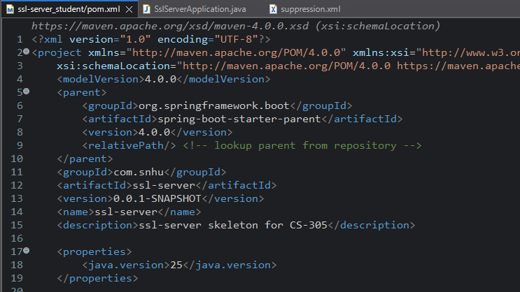
The updated versions successfully addressed the critical vulnerabilities identified in the previous scan, and no additional package dependencies required pinning for fixes.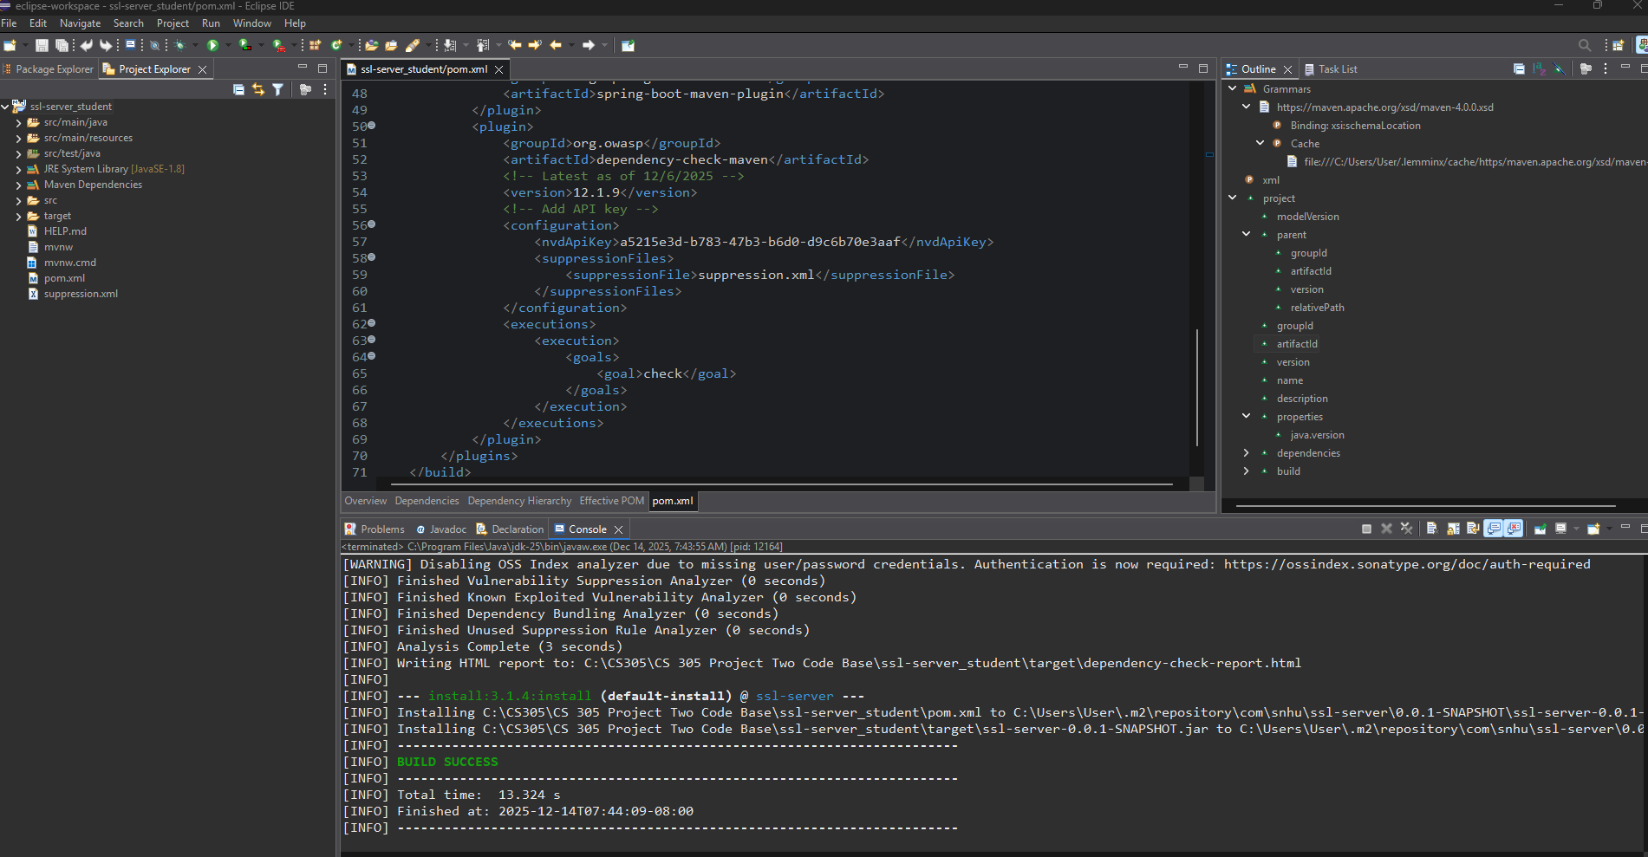

The updated dependency analyzer generated a new report reflecting the latest versions, and, importantly, no critical vulnerabilities or CVEs were detected.
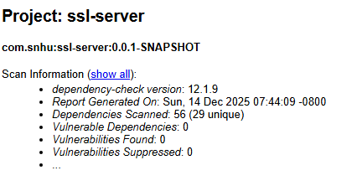

Functional Testing

Insert a screenshot below of the refactored code executed without errors.
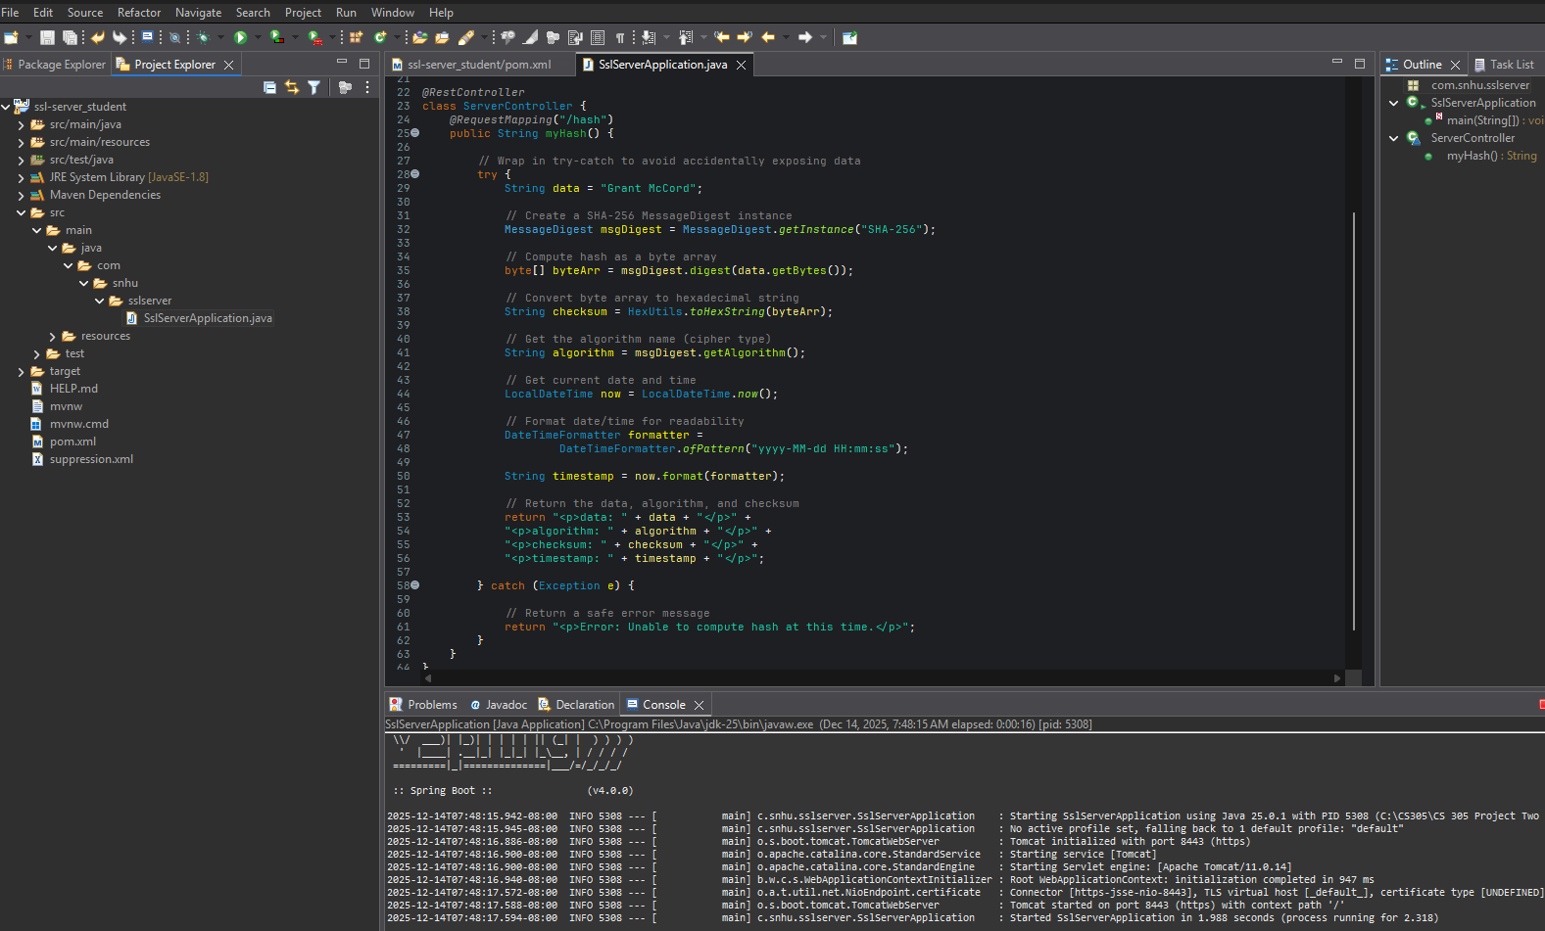

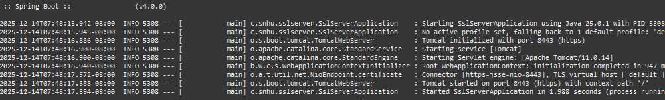

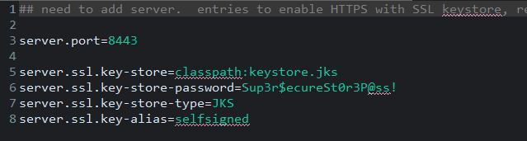

Summary

In this project, I implemented multiple secure software practices for a Spring Boot server. I integrated SHA-256 hashing to verify data integrity, enabled HTTPS using a self-signed SSL certificate stored in a Java KeyStore, and ensured secure communication throughout the application. I also updated the project’s pom.xml to upgrade Spring Boot to 4.0.0 and Java to version 25, addressing dependency vulnerabilities identified in previous scans. The OWASP Dependency-Check plugin was configured to automatically scan dependencies during builds. These measures ensure the application adheres to best practices for secure coding, data verification, dependency management, and server-side data protection.
In implementing multiple layers of security for the server application, I followed a systematic approach addressing key aspects of application security, including data protection, secure communication, and dependency management. The process can be broken down into several key steps:
- Assessing Security Requirements:
I began by identifying the types of sensitive data handled by the application and any client needs, such as long-term storage of confidential documents. Understanding what data required protection guided the selection of hashing and secure communication techniques.
- Data Integrity:
Ensuring that data is not tampered with in transit or at rest is critical. I integrated SHA-256 hashing for critical data, providing a reliable way to verify data integrity. Hashing passwords and other sensitive information prevents direct exposure even in the event of a breach, as hashes are computationally infeasible to reverse (Stallings, 2020).
- Secure Communication:
To protect data in transit, I enabled HTTPS using a self-signed SSL certificate stored in a Java KeyStore. HTTPS ensures that communication between clients and the server is encrypted, mitigating risks such as eavesdropping and man-in-the-middle attacks. The self-signed certificate was used for development and testing, with the option to replace it with a trusted CA certificate for production deployment.
- Dependency and Build Security:
Recognizing that many vulnerabilities originate from third-party libraries, I updated the pom.xml to upgrade Spring Boot to version 4.0.0 and Java to version 25, addressing known vulnerabilities flagged in prior scans. I also configured the OWASP Dependency-Check plugin to automatically scan all dependencies during builds, allowing for continuous monitoring of security issues in libraries.
- Layered Approach:
Each security measure complements the others, creating a multi-layered defense. HTTPS secures data in transit, SHA-256 hashing preserves data integrity, and dependency scanning reduces the risk of introducing vulnerable components. Together, they establish a defense-in-depth strategy, making the application more resilient against a range of potential attacks.
- Ongoing Security Practices:
Security is an ongoing effort. I set up automated scans and monitoring to continually evaluate dependencies for vulnerabilities and reviewed secure coding practices throughout development. This ensures that security measures evolve with the application and emerging threats.

Industry Standard Best Practices

For this project, several industry-standard best practices were applied to ensure the security of the server and its dependencies. One key practice is secure data storage and transmission, which I implemented by enabling HTTPS using a self-signed SSL certificate stored in a Java KeyStore and integrating SHA-256 hashing for data integrity. HTTPS protects data in transit from eavesdropping, while SHA-256 provides a consistent method for verifying that data has not been modified, ensuring confidentiality and integrity of financial and personal information (Stallings, 2020; NIST, 2015).
Another critical practice is managing dependencies and applying security patches. Using the OWASP Dependency-Check plugin, I scanned all project dependencies to identify known vulnerabilities. By keeping libraries up-to-date, the project adheres to secure dependency management standards, minimizing the risk of exploits through third-party components (Bhattacharya & Chatterjee, 2019). This proactive approach reflects the principle of regular security updates, which is essential in mitigating emerging cyber threats (Khalil, 2025).
Additional best practices, though partially outside this project’s scope, include the principle of least privilege and input validation. While this server has minimal user input and no complex roles, restricting access to necessary functions and validating inputs will be important for future expansions. Proper error handling and logging were also implemented using try-catch blocks to prevent sensitive data from being exposed in server errors while maintaining the ability to detect anomalies (Stallings, 2020). Together, these measures create a strong foundation for building secure applications that are resilient against both internal and external threats.

References
National Institute of Standards and Technology. (2015). FIPS 180-4: Secure Hash Standard (SHS). U.S. Department of Commerce. https://doi.org/10.6028/NIST.FIPS.180-4
Bhattacharya, T., & Chatterjee, R. (2019). Data at rest, data at risk: Evaluating encryption and access control mechanisms in cloud storage systems. International Journal of Trend in Scientific Research and Development, 3(6), 1462–1478. https://doi.org/10.5281/zenodo.15406707
Federal Trade Commission. (n.d.). Safeguards rule: What your business needs to know. https://www.ftc.gov/business-guidance/resources/ftc-safeguards-rule-what-your-business-needs-know
Khalil, M. (2025, September 28). Cybercrime 2025: $10.5T losses & shocking new statistics. DeepStrike. https://deepstrike.io/blog/cybercrime-statistics-2025
PCI Security Standards Council. (n.d.). Payment Card Industry Data Security Standard (PCI DSS). https://www.pcisecuritystandards.org/standards/pci-dss/
U.S. Securities and Exchange Commission. (n.d.). Regulatory guidance. https://www.sec.gov
Stallings, W. (2020). Cryptography and network security: Principles and practice (8th ed.). Pearson.
U.S. Securities and Exchange Commission. (n.d.). Retention of records relevant to audits and reviews. https://www.sec.gov/rules-regulations/2003/01/retention-records-relevant-audits-reviews

